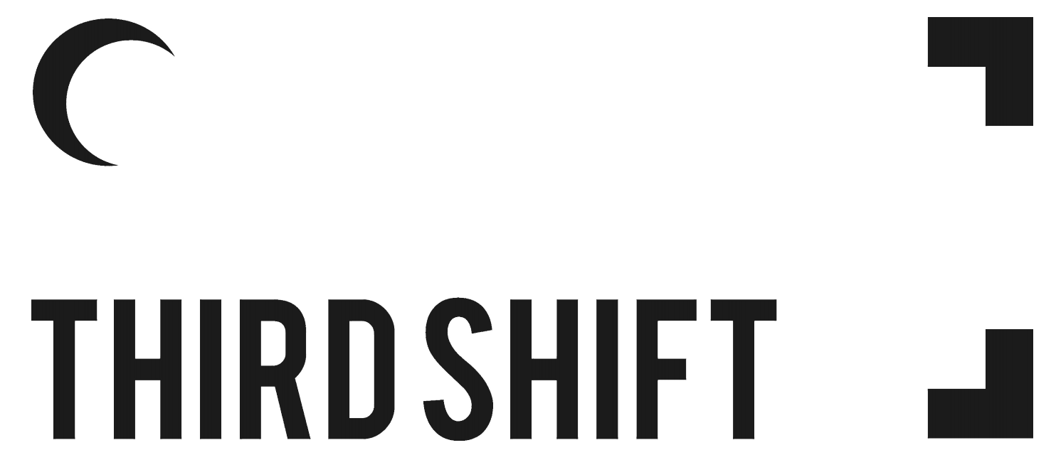

2022 Application Form

DEADLINE FOR SUBMISSION: March 13, 2022 (11:59pm Atlantic)
SUBMIT TO: <thirdspacesubmissions@gmail.com> with subject line THIRD SHIFT 2022

You may submit this application in the official language of your choosing (applications submitted in French will be translated to English for the selection process).

Artist (or collective) name
Artist(s) pronouns
Contact email
Contact phone #
Where are you currently located?

Title of the proposed project
Medium / type of artwork
Themes addressed in the artwork

Artist bio (max. 150 words)
We welcome applicants to self-identify in any way that is important to their identity

Project proposal (max. 300 words)

How does your proposed project connect to this year’s theme, PERIPHERIES? (max. 150 words)

Briefly explain why it is important that your proposed project be shared in Saint John and how it is relevant to our community. (max. 100 words)

Technical requirements (access to power sources, projectors, darkened space, etc.)

Preferred location (is there a specific location in Uptown Saint John you have in mind? If not, give us an idea of the type of space you are envisioning, i.e. hidden vs. public, indoors vs. outdoors, etc.)

Is there any additional info the festival organizers should know?
For example, a contingency plan if your proposed installation is at risk of damage due to weather, or would need to be adapted in some way if conditions are not ideal. This could help clear up some questions during the selections process (Optional)

Materials and production fees:
Additional funds are available to artists to help with the realization of their THIRD SHIFT installations. Please indicate if you require financial support for materials or production and the approximate amount.

- Yes, I require financial support for materials or production
- No, I do not require additional support

If yes, the approximate amount required:

Are you willing to offer an artist talk or workshop in conjunction with your project?

- Yes, I would like to be considered
- No, I would not like to be considered

If yes, what topics would your talk or workshop cover?

Supporting files list (images or video links). Include title, medium, and dimensions, if applicable. *please ensure attached images are numbered accordingly

1.

2.

3.

4.

5.

6.

7.

8.

Accessibility needs
Third Space can arrange for closed captioning, ASL interpretation, translation of artworks at the applicant’s request, or any other accessibility requirement up to $150. Please indicate if you expect to utilize one or more of these services in your proposal, or if you require access to accessibility funds.

- Yes, I would like to utilize one or more of these services
Which services would you like to use?

◻︎ Closed captioning
◻︎ ASL Interpretation
◻︎ Translation (Which language(s)? _____________________________)
◻︎ Audio description
◻︎ Other

Other:

